**Chatbot Integration with Facebook Messenger, Slack, and Deployment on IBM Cloud**

**Executive Summary**

The project aimed to develop a chatbot and seamlessly integrate it with Facebook Messenger and Slack. Additionally, the chatbot was deployed on IBM Cloud to ensure reliable hosting. The chatbot's primary objective was to provide informative and accurate responses while maintaining a natural conversation flow. The following report outlines the key steps and achievements of this project.

**Project Objectives**

1. Develop a chatbot capable of understanding and responding to user queries effectively.

2. Create integration with Facebook Messenger and Slack for user accessibility.

3. Implement natural language understanding (NLP) to improve user interactions.

4. Deploy the chatbot on IBM Cloud for robust hosting and accessibility.

5. Continuously test, refine, and maintain the chatbot for optimal performance.

**Project Steps**

**Step 1:** Define Requirements

The project began with a thorough definition of the chatbot's requirements, including its target audience, purpose, and expected features.

**Step 2:** Choose a Chatbot Platform

We selected the [IBM watson assistant] for building the chatbot. This choice was made based on its compatibility with Facebook Messenger and Slack integration.

**Step 3:** Develop the Chatbot

The core functionality of the chatbot was developed, focusing on NLP capabilities, conversation management, and integration with external data sources.

**Step 4:** Create Accounts on Facebook Developer and Slack Developer Platforms

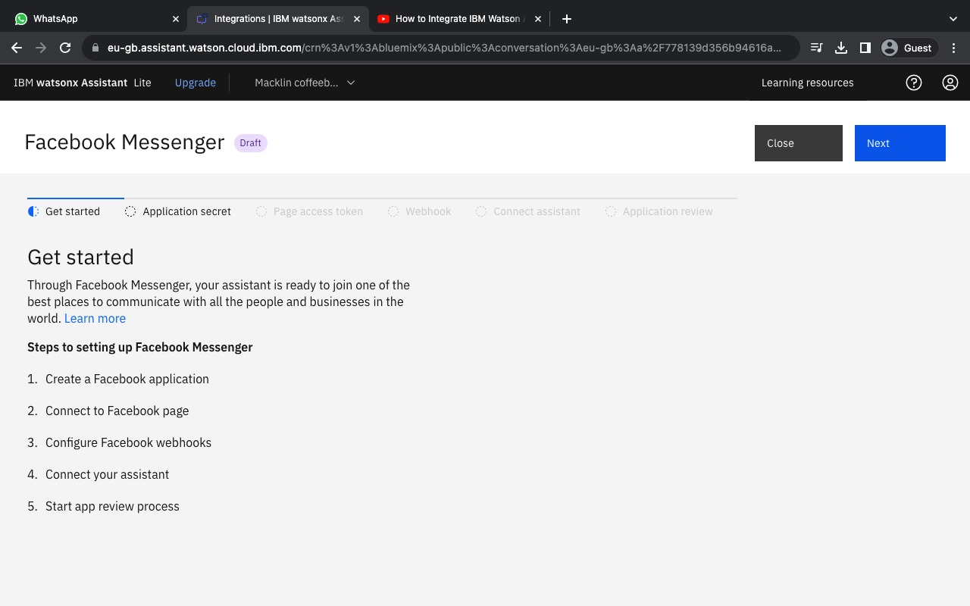

We acquired developer accounts on both Facebook and Slack platforms to obtain necessary credentials and permissions for integration.

**Step 5:** Integrate with Facebook Messenger

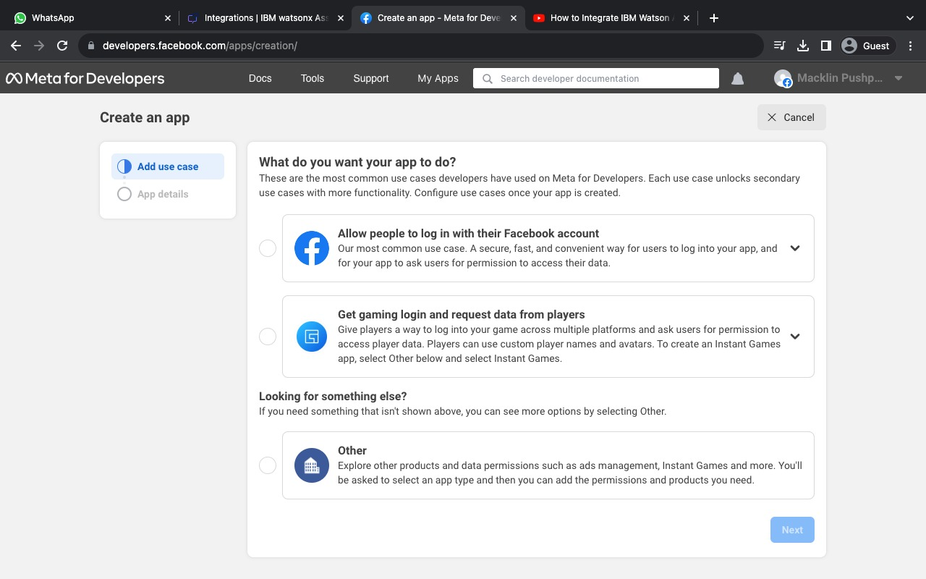

- Created a Facebook App and configured it to use the Messenger platform.

- Set up webhooks to receive incoming messages and events.

- Implemented secure authentication using the App Secret.

- Subscribed to specific events for the chatbot to respond to.

- Developed Facebook - specific features, including quick replies, templates, and persistent menus.

- Thoroughly tested the chatbot on Facebook Messenger.

**Step 6:** Integrate with Slack

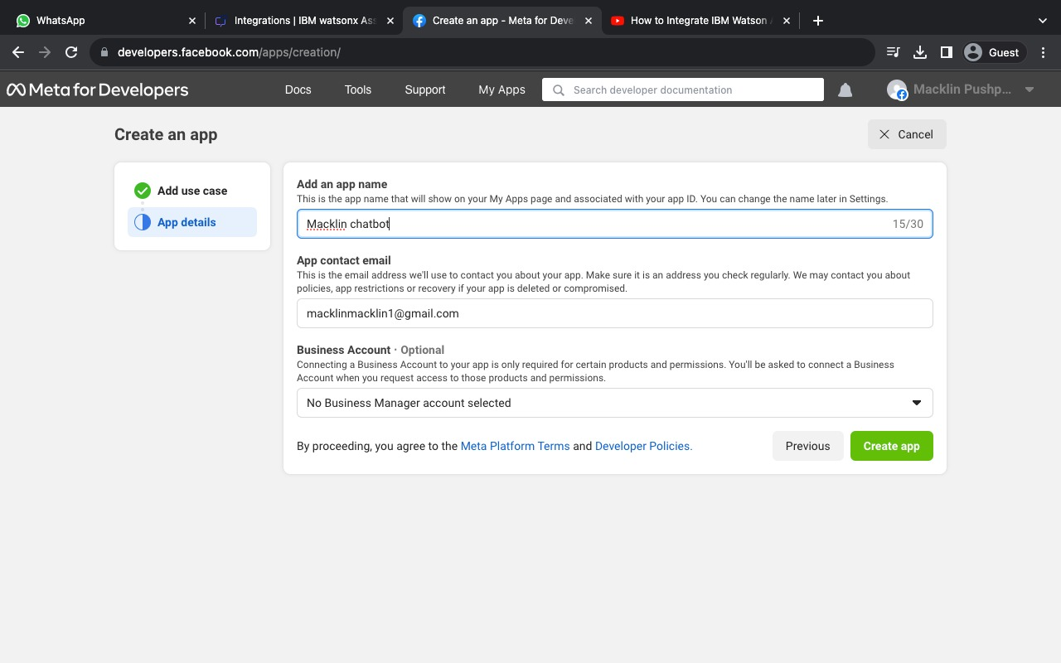

- Created a Slack App and configured it for the Slack platform.

- Configured incoming and outgoing webhooks.

- Implemented secure authentication using OAuth tokens.

- Defined custom commands and interactive messages.

- Subscribed to relevant events.

- Thoroughly tested the chatbot on Slack.

**Step 7:** Implement Natural Language Understanding

NLP techniques and models were incorporated to enhance the chatbot's ability to understand user input, context, and deliver relevant responses.

**Step 8:** Test and Refine

Extensive testing was conducted on both Facebook Messenger and Slack. User feedback was gathered and incorporated to refine the chatbot's responses and capabilities, ensuring accuracy and improving the user experience.

**Step 9:** Deployment on IBM Cloud

The chatbot was deployed on IBM Cloud for reliable hosting. This step ensured that the chatbot is accessible to users and can scale as needed.

**Step 10:** Maintenance and Updates

Regular maintenance and updates were performed to keep the chatbot relevant and accurate. This included handling new user queries, adding new features, and staying updated with platform API changes.

**Purpose of API key in IBM Cloud:**

An API key in IBM Cloud, used for integrating Watson Assistant with Facebook Messenger, serves as a form of authentication and authorization to ensure secure communication between the two services. Here's the purpose of an API key in this context:

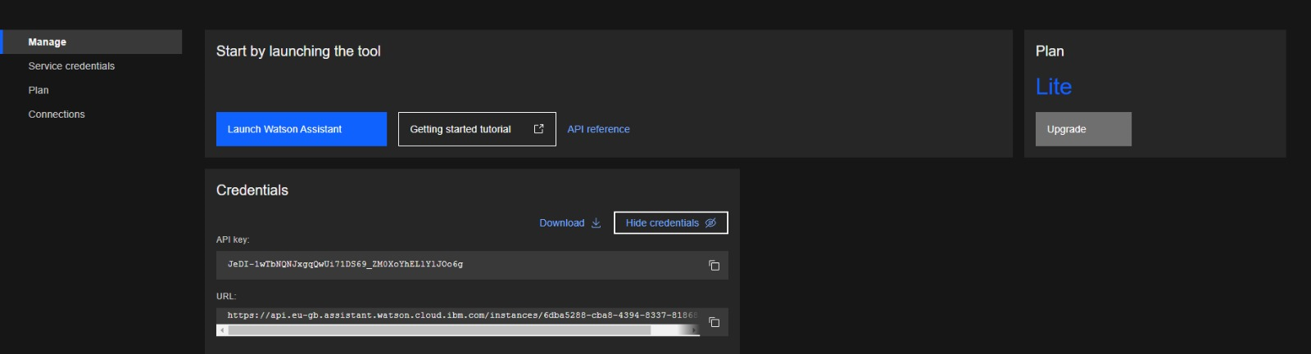

1. Authentication: An API key acts as a form of authentication to verify the identity of the requester (in this case, your Facebook Messenger chatbot) when it connects to the Watson Assistant service on IBM Cloud. It helps ensure that only authorized entities can access and use the Watson Assistant service.

2. Authorization: API keys can also be used to control and restrict access to specific resources and functionalities within Watson Assistant. With the API key, you can define which actions the Messenger chatbot is allowed to perform within Watson Assistant, such as sending and receiving messages, accessing user data, or managing conversation flows.

3. Secure Communication: By requiring an API key, you establish a secure connection between Facebook Messenger and Watson Assistant, preventing unauthorized access and potential misuse of your Watson Assistant instance. This added security layer helps protect sensitive user data and ensures the integrity of the chatbot's interactions.

4. Usage Tracking: API keys can also be used for tracking and monitoring the usage of the Watson Assistant service. This enables you to keep an eye on how your Facebook Messenger chatbot is utilizing the service and whether it's within any usage limits or quotas.

To integrate Watson Assistant with Facebook Messenger, you typically generate an API key in the IBM Cloud platform, configure your Facebook Messenger chatbot to use this key, and then set up the necessary API calls to interact with Watson Assistant securely. This API key ensures that your integration is both secure and properly managed, allowing your chatbot to leverage the capabilities of Watson Assistant while maintaining control and protection of your Watson Assistant resources.

**Conclusion**

This project successfully integrated a chatbot with Facebook Messenger and Slack, deploying it on IBM Cloud for reliable and scalable hosting. It achieved the objectives of providing informative and accurate responses while maintaining a natural conversation flow. The project emphasizes the importance of continuous improvement and user feedback for the long-term success of the chatbot.